Advanced Software Engineering – Week #2 Assignment 1

Baseline SCIs

**Context/Overview:** This assignment requires baselining of software configuration items (SCIs), and auditing items.

**Resources to consult:**

Chapter 22

·                  Lecture 1: Software Configuration Item Identification

·                  Lecture 2: Software Change Control and Auditing

·                  Lecture 3: Git

·                  Page 594, Figure 22.1 Baselines and Candidate CIs

**Instructions:**

1. **Determine baselines for an agile approach to creating the SAMS website. Baselines are milestones and associated Configuration Items.**

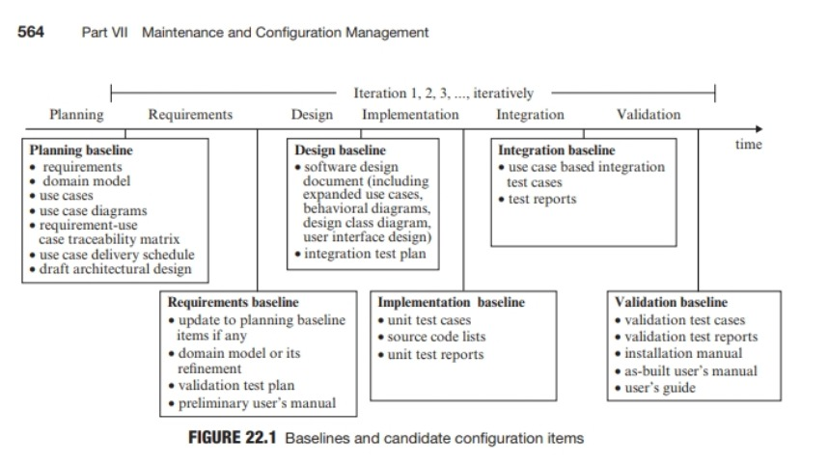

1. **Identify the baselines (milestones)**
2. Our project will complete in 3 iterations.

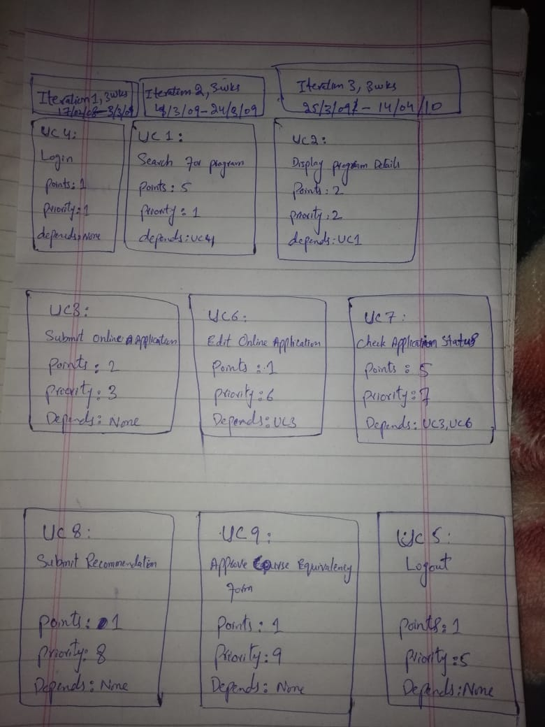

* The project baseline is the starting point of your project plan. Basically, the baseline in project management talks about the scope, initial cost, workflow and schedule of your projects. Setting the project baseline should be done at the start of the project otherwise the project managers will not have a mechanism to make important measures along with the project execution. It works as a measure so that the project will not deviate from the plan.

**Iteration 1, 2, 3**

Iteration 2, 3weeks

4/03/09

To

24/3/09

Iteration 3, 3weeks

25/03/09

To

14/04/10

Iteration 1, 3weeks

17/02/08

To

3/3/09

Each iteration and its completion time is mentioned above:

**Explanation:**

* The [project baseline](https://project-management.com/the-project-baseline-a-project-management-definition/) document will change whenever the project owner, team members or the client requests a change in the project process.
* Changing the baseline document will equip team members with the updated record for project change.
* Quality benchmark, as quality increase the project cost.
* Project schedule, as making timeline adjustments increase the project completion time

**Example:**

1. Look at this example to understand the [importance of baseline](https://uplandsoftware.com/psa/resources/glossary/baseline/). Let’s assume that the project is set to complete in eight weeks and your baseline schedule says that the project will complete in six weeks. You will inform your team that there is a serious problem so that they can work more quickly to improve the progress.

**The start of the project, each iteration, and the project close are milestones - Identify each iteration by the iteration number.**

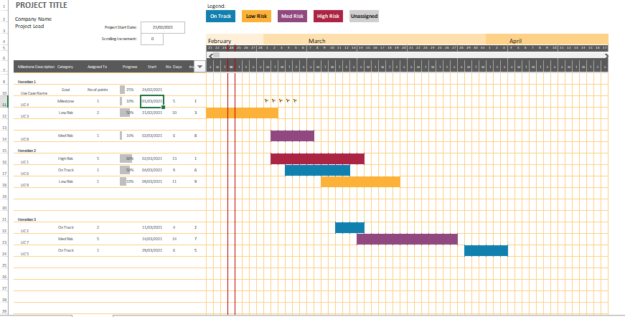

**Development phases within each iteration are milestones.**

**Sprint Planning Process:**

1. **Do a retrospective meeting** to discuss the previous sprints and lessons learned.
2. **Run a sprint planning meeting**to analyze the release plan and update it according to velocity in recent sprints, changes to priorities, new features, or idle time that wasn’t planned for in the release.
3. **Make sure user stories are detailed enough**to work on. Elaborate on tasks that are not well defined, to avoid surprises.
4. **Break down user stories into specific tasks**. For example, the user story “view tasks assigned to me” can be broken up into UX design of a “my tasks screen”, back-end implementation, and front-end development of the interface. Keep size of tasks small, no more than one work day.
5. **Assign tasks to team members**and confirm that they are committed to performing them. In the agile/scrum framework this is done by the Scrum Master.
6. **Write the tasks on (physical) sticky cards**and hang them up on a large board visible to the entire team. All the user stories in the current sprint should be up on the board.
7. **Track progress of all the tasks**on a grid, by recording who is responsible for completing each task, estimated time to complete it, remaining hours, and actual hours used. This time tracking should be updated by all team members and visible to everyone.
8. **Track velocity using a burndown chart.**During the sprint, use the team’s time tracking to calculate a chart showing the number of tasks or hours remaining, vs. the plan. The slope of the burndown chart shows if we are on schedule, ahead, or behind schedule.

**Example link is below:**

[Project issue tracker1 example.xlsx](Project%20issue%20tracker1%20example.xlsx)

In the lab assignment for this week a Git repository will be created to store your CIs. During the lab, keep in mind that the directory structure that you want to setup in your repository should reference the baselines identified

**i.    SAMS**

**1. Planning**

The planning phase is when the project plans are documented, the project deliverables and requirements are defined, and the project schedule is created. It involves creating a set of plans to help guide your team through the implementation and closure phases of the project.

1. **Requirement**

This is the initial phase of the development process wherein the development team works closely with the customer to determine the customer's requirements for the product.

1. **Design**

In the design phase, one or more designs are developed, with which the project result can apparently be achieved.

1. **Implementation**

This phase involves the construction of the actual project result. Programmers...

1. **Integration**

Integrate the component

1. **Validation**

To validate the project according to requirements

1. **close project:**

Close Project or Phase is the process of finalizing all activities for the project, phase, or contract. The key benefits of this process are the project or phase information is archived, the planned work is completed.

1. **Usually, the project baseline has three components:**

When you are given a new project, the project manager needs to make the project plan and includes the three major components of the project baseline.

1. **Create project scope baseline**

The project scope baseline is one of the most important documents in your project plan. While creating a project scope baseline you will answer the following questions:

* What are your [project deliverables](https://www.ntaskmanager.com/blog/guide-to-project-deliverables-for-your-project/), with key milestones and dependencies?
* What do you want to achieve from your project?
* What problem do you need to solve with your project?
* What are your project resources?
* Identify the work that needs to be done?

After you have answered the above questions, then you will develop a [work breakdown structure](https://www.workamajig.com/blog/guide-to-work-breakdown-structures-wbs) so that bigger goals are defined with smaller achievable items.

1. **Create project cost baseline**

In the project cost baseline, you will need to identify the cost that is expected to incur on your project. Try to estimate the cost of each task. Come up with a cost amount taken from the suppliers during your surveys and calculate the average wage rate that will be given to your workforce.

1. **Create a project schedule baseline**

The project schedule baseline is dependent on your above two; cost and scope baselines. As your tasks and activities are identified in your project you will be creating the project schedule baseline.

 First, identify the resources for all the tasks and create an estimate of how much time each task will require to be fully completed. Use these estimates to develop the schedule for the project and assign team members to each task by defining the activity timeframe. The start and end dates of the activities are important in the schedule baseline.

**2. Identify SCIs associated with each baseline.**

Iteration 2, 3weeks

4/03/09

To

24/3/09

Iteration 3, 3weeks

25/03/09

To

14/04/10

Iteration 1, 3weeks

17/02/08

To

3/3/09

Each iteration and its completion time is mentioned above:

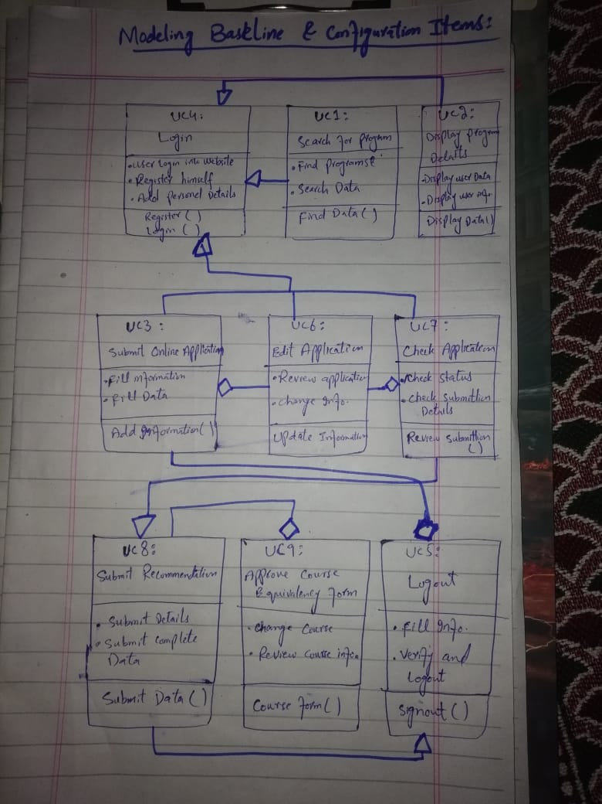

Example: C1: Project deliver to customer with in project Duration

C2: Manage and control cost estimation

Apply cost estimation technique to handle project cost.

* Products delivered to the customer.
* Designated internal work products.
* Acquired products.
* Tools and other capital assets of the project's work environment.
* Other items used in creating and describing these work products.

3.    **Define a naming scheme for each type of CI identified.**

To change control:

Any changing in project to handle project cost and duration.

For example

Client requested to change in project then change controls and handle project cost and duration

**Following is the naming scheme for type 1 of CI**:

* Configuration Identification
* Baselines
* Change Control
* Configuration Status Accounting
* Configuration Audits and Reviews

1. **Identify the events that will mandate changes to each type of CI identified**

SDLC model for control changes to configuration Items

Baselines are a mechanism to control change to configuration items The Waterfall

Model was the first Process Model to be introduced. It is also referred to as a linear-sequential life cycle model. It is very simple to understand and use. In a waterfall model, each phase must be completed before the next phase can begin and there is no overlapping in the phases. To control the change.

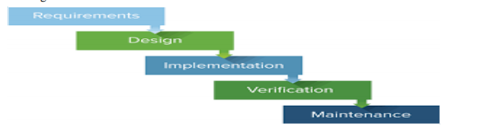

**5.    Describe what information should be included in an ECP, engineering change proposal.**

The Engineering Change Proposal (ECP) shall be prepared in contractor format.

The ECP content shall include, where applicable, the following information:

* The change priority, change classification, and change justification
* A complete description of the change to be made and the need for that change
* Complete listing of other configuration items impacted by the proposed change and a
* Description of the impact on those CIs.
* Proposed changes to documents controlled by the government.
* Proposed serial (or lot) number effectivities of units to be produced in, or retrofitted to,
* The proposed configuration.
* Recommendation about the way a retrofit should be accomplished.
* Impacts to any logistics support elements (such as software, manuals, spares, tools, and
* Similar) being utilized by government personnel in support of the product.
* Impacts to the operational use of the product
* Complete estimated life-cycle cost impact of the proposed change.
* Milestones relating to the processing and implementation of the engineering change

**6.    Change Control Auditing**

**a.    Describe the steps needed for a baseline to transition from TBE to a formal baseline.**

Change control is a procedural method which ensures quality and consistency when

Changes are made in the configuration object. In this step, the change request is

Submitted to software configuration manager.

**b.    Describe using Cost estimation technique to ensure that the identified CIs entered in the SCM system for change control. (Visual inspection works for small projects)**

* Control ad-hoc change to build stable software development environment. Changes
* are committed to the repository
* The request will be checked based on the technical merit, possible side effects and
* overall impact on other configuration objects.
* It manages changes and making configuration items available during the software
* lifecycle.

**c.     Describe how CIs will be checked for correctness.**

(Example: client want changing in project then change request correct by developer.)

Keeps a record of all the changes made to the previous baseline to reach a new

* baseline
* Identify all items to define the software configuration
* Monitor status of change requests
* Complete listing of all changes since the last baseline
* Allows tracking of progress to next baseline
* Allows to check previous releases/versions to be extracted for testing

**d.    Describe how change control auditing will ensure the changes in approved ECPs are implemented in a timely manner.**

Configuration auditing is performed by auditors (external to the development team) who are in charge of determining if the defined processes are being followed and to ensure that the SCM goals are satisfied – Determine whether software engineering

and organizational standards (e.g., documentation standards, coding conventions)

been properly followed.

* Configuration auditing is conducted by auditors by checking that defined processes
* Are being followed and ensuring that the SCM goals are satisfied.
* To verify compliance with configuration control standards. auditing and reporting the
* changes made
* SCM audits also ensure that traceability is maintained during the process.
* Ensures that changes made to a baseline comply with the configuration status reports
* Validation of completeness and consistency.

**Criteria:** (# pages, APA format, etc.) APA format

Grading Rubric

|  |  |  |
| --- | --- | --- |
| Description | Points | Your Points |
| Determined baselines for agile approach to developing the SAMS project | 15 |  |
| Configuration items, or CIs associated with each base line were identified. | 15 |  |
| A CI naming scheme was identified | 15 |  |
| Described information that should be included in an engineering change proposal (ECP). | 15 |  |
| Described the steps needed for a baseline to      transition from TBE to a formal baseline. | 10 |  |
| Described methods to ensure that the identified CIs entered in the SCM system for change control. | 10 |  |
| Described how CIs will be checked for correctness. | 10 |  |
| Described how change control auditing will ensure the   changes in approved ECPs are implemented in a timely manner. | 10 |  |